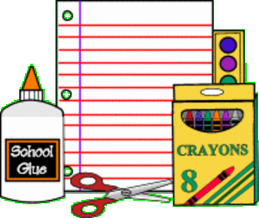
Mrs. Gordon’s 2015-2016 Homeroom Supply List
- 24 pack Crayola crayons
- scissors with metal blades
- wooden pencils (24 count, sharpened if possible)
- pink erasers (2 count)
- 1 folder with child’s name
- 1 spiral notebook with child’s name (1 subject)
- Kleenex (2 boxes)
- paper towels (1 roll) girls
- Disinfecting wipes (1 container)
- Ziploc bags (1 box snack, quart, or gallon size)
- Index Cards (1 pack) boys

Wish List
If you are able to donate any of the items below it would be greatly appreciated!
- 1 bag Starburst Candies
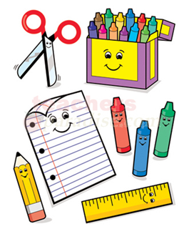
- Paper plates (1 pack)
- Highlighters (any color, amount, and size)
- Glue sticks (3 count)
- Baby wipes (1 container)

